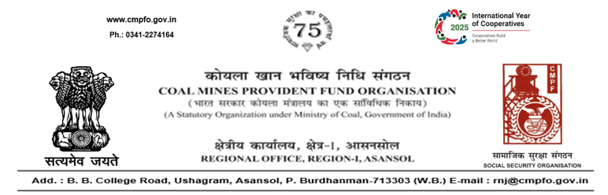
SL. No. :114
CPF/Misc/PA Cell/R-1/ASN/ Date:02-01-2026
To
The Regional Commissioner
C.M.P.F, Singrauli
PO-Jayant Dist-Singrauli-486890
Madhya Pradesh

Sub- Supply of Extract of "VV" statement

Ref:- Your office letter no. CPF/SING/16/L.C. in our out/Extract/2345 dated 16/12/2025.

Sir,
On the subject and reference cited above, please find enclosed herewith the extract in respect ofSmt. Dewanti pandey , CMPF A/C No- RNJ/11/212 as desired.

Yours faithfully,

(Ajay Kumar Singh)
Encl- As above Regional Commissioner - I

